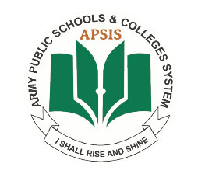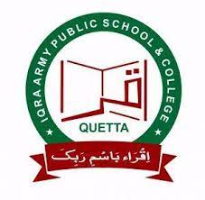

**IQRA ARMY PUBLIC SCHOOL AND COLLEGE**

**MOCK EXAMINATION DECEMBER 2024**

**ISLAMIYAT** **2058**

**PAPER 2 GRADE:O-ll**

**1 hour 30 minutes**

Candidates answer on the Question Paper.

No Additional Materials are required.

**READ THESE INSTRUCTIONS FIRST**

Write your name on all the work you hand in.

Write in dark blue or black pen on both sides of the paper.

Do not use staples, paper clips, glue or correction fluid.

DO **NOT** WRITE IN ANY BARCODES.

Answer **Question 1**, **Question 2** and **two** other questions.

All answers must be in continuous prose.

At the end of the examination, fasten all your work securely together.

The number of marks is given in brackets [ ] at the end of each question or part question.